**Module 1: Understanding of Hardware and Its Components**

* **1. Which of the following is NOT a component of the CPU?**
  + **Answer:** RAM
* **2. What is the function of RAM in a computer?**
  + **Answer:** The function of RAM (Random Access Memory) is to store data and program instructions that the CPU is currently using. It's a type of temporary, volatile memory, meaning its contents are erased when the computer is turned off.
* **3. Which of the following is a primary storage device?**
  + **Answer:** None of the options listed (HDD, SSD, SD card) are considered primary storage in the same sense as RAM, which is directly accessed by the CPU. The question is flawed based on the provided options. However, if we must choose from the given list, a solid-state drive (SSD) is a form of permanent storage that is faster than a hard disk drive (HDD) and is sometimes colloquially referred to as primary storage.
* **4. What is the purpose of a GPU?**
  + **Answer:** The purpose of a GPU (Graphics Processing Unit) is to handle all the graphics and image processing for a computer. It's especially important for rendering images, animations, and video, which is why it's a key component for gaming and video editing.
* **5. True or False: The motherboard is the main circuit board of a computer where other components are attached.**
  + **Answer:** True.
* **6. True or False: A UPS (Uninterruptible Power Supply) is a hardware device that provides emergency power to a load when the input power source fails.**
  + **Answer:** True.
* **7. True or False: An expansion card is a circuit board that enhances the functionality of a component.**
  + **Answer:** True.
* **8. Explain the difference between HDD and SSD.**
  + **Answer:** An HDD (Hard Disk Drive) is a traditional storage device that uses spinning platters and a mechanical arm to read and write data. An SSD (Solid-State Drive) uses flash memory to store data and has no moving parts. The main differences are that SSDs are much faster, more durable, and use less power than HDDs.
* **9. Describe the function of BIOS in a computer system.**
  + **Answer:** The function of BIOS (Basic Input/Output System) is to perform a Power-On Self-Test (POST) when a computer is first turned on. It initializes and tests the hardware components and then loads the operating system from a storage device.
* **10. List and briefly explain three input devices commonly used with computers.**
  + **Answer:** Three common input devices are:
    1. **Keyboard:** Used to input text, numbers, and commands into the computer.
    2. **Mouse:** Used to control the cursor on the screen and interact with graphical elements.
    3. **Microphone:** Used to capture audio, allowing for voice commands, recording, and communication.
* 11. Identify and label the following components on a diagram of a motherboard: ● CPU ● RAM slots ● SATA connectors● PCI-E slot.

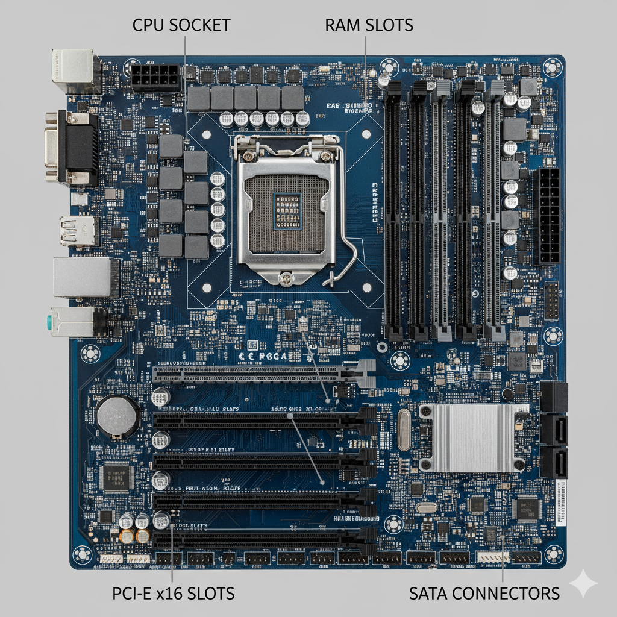

* **12. Demonstrate how to install a RAM module into a computer.**
* Installing a RAM module is a straightforward process, but it requires care to avoid damaging the components. Here are the general steps:

1. **Safety First:** Before you begin, turn off and unplug the computer. Press the power button a few times to drain any residual power from the motherboard. You should also wear an anti-static wrist strap or touch a metal part of the computer case to ground yourself and prevent static electricity from damaging the components.
2. **Open the Case:** Remove the side panel of your computer case to access the motherboard.
3. **Locate the RAM Slots:** The RAM slots are long, thin sockets on the motherboard, usually located near the CPU. They have small clips on either end that hold the RAM module in place.
4. **Open the Clips:** Push down on the clips on both ends of the RAM slot. They should click open.
5. **Align the RAM Module:** Take the new RAM module out of its packaging. Notice the notch (or notches) on the bottom edge of the RAM stick. This notch must line up perfectly with the key in the RAM slot. The module is keyed to fit in only one orientation.
6. **Insert the Module:** With the clips open, gently but firmly push the RAM module straight down into the slot. Apply even pressure on both ends of the stick until the clips snap back into place, securing the module.
7. **Verify and Close:** Double-check that the clips have fully closed and that the RAM module is seated evenly. Close the computer case, plug everything back in, and power on the computer. It may take a moment for the system to recognize the new RAM.

* **13. Discuss the importance of proper cooling mechanisms in a computer**
* Proper cooling is one of the most critical aspects of a computer system. As electronic components like the CPU and GPU perform calculations, they generate heat. Without an effective way to dissipate this heat, the components can overheat, leading to several problems:
* Thermal Throttling: The computer will intentionally reduce the performance of the components to lower the temperature. This results in stuttering, lag, and poor overall performance.
* Reduced Lifespan: Prolonged exposure to high temperatures can degrade and shorten the lifespan of electronic components.
* System Failure: In extreme cases, overheating can cause the system to shut down unexpectedly or even lead to permanent hardware damage.
* Common Cooling Methods
* Air Cooling: This is the most common and cost-effective method. It involves using a heatsink with fins to draw heat away from a component (like the CPU) and a fan to blow air across the fins, dissipating the heat.
* Liquid Cooling (Water Cooling): This method uses a liquid coolant to transfer heat more efficiently than air. A water block is placed on the component to absorb heat, which is then pumped through tubes to a radiator. The radiator, equipped with fans, cools the liquid before it returns to the component. Liquid cooling is more effective and quieter than air cooling but is also more complex and expensive.
* Case Fans: These fans are installed on the computer case itself to create airflow. They draw cool air in from the front and push hot air out from the back or top, ensuring that heat doesn't build up inside the system.
* 14. Explain the concept of bus width and its significance in computer architecture.

In computer architecture, a **bus** is a set of parallel wires or pathways that transfer data between different components of the computer. The **bus width** refers to the number of parallel lines that make up the bus. It determines how many bits of data can be transferred simultaneously.

**Significance:**

* **Data Transfer Speed:** The bus width is directly proportional to the amount of data that can be transmitted at one time. A wider bus can transfer more data in a single cycle. For example, a 64-bit bus can transfer 64 bits of data at once, while a 32-bit bus can only transfer 32 bits. This means a wider bus significantly increases the speed of data transfer between the CPU, RAM, and other components.
* **System Performance:** The bus width is a key factor in overall system performance. If the bus is too narrow, it can become a bottleneck, limiting the performance of other high-speed components, even if they are very fast on their own. For instance, a fast CPU can't reach its full potential if the bus connecting it to the RAM is too slow to feed it data quickly enough.
* **Addressing and Memory:** Bus width also impacts the amount of memory a system can address. A 32-bit address bus can access up to 4 gigabytes of memory (232 bytes), while a 64-bit address bus can access a significantly larger amount (264 bytes). This is why modern computers use 64-bit architecture to utilize more than 4GB of RAM.